

Plenty River Local Management Plan 2024

Table of contents

Acknowledgement of Traditional Owners 4

Disclaimer 5

Glossary 6

1. Introduction 9

1.1 Background 9

1.2 Management Objectives 9

1.3 Plenty River Local Management Plan 10

1.4 Environmental Values 12

1.5 Environmental Flows 12

2. Water Use 15

2.1 Licenced Water Entitlements 15

2.2 Domestic and Stock Use 16

2.3 Groundwater 17

3. Surface Water Management 18

3.1 Allocation 18

3.2 Environmental Flows 19

3.4 Surface Water Licences 19

3.4.1 New Licences 19

3.4.2 Trades and Transfers 20

3.4.3 New Dams 20

4. Monitoring, Evaluation & Reporting 22

5.1 Surface Water Flows 22

5.2 Meter Readings 22

5.1 Annual Reporting 23

4.2 Review of the Plan 24

References 25

Appendix -1 25

LICENCE CONDITIONS 25

# Acknowledgement of Traditional Owners

**We acknowledge the Victorian Traditional Owners and their Elders past and present as the original custodians of Victoria’s land and waters and the Wurundjeri Woi-Wurrung as the Traditional custodians of the Plenty River. We pay our respects to their Elders past and present and to the ongoing living culture of Aboriginal and Torres Strait Islander Peoples.**

Disclaimer

This publication may be of assistance to you but Melbourne Water and its employees do not guarantee that the publication is without flaw of any kind or is wholly appropriate for your particular purposes and therefore disclaims all liability for any error, loss or other consequence which may arise from you relying on any information in this publication.

© Copyright May 2024

Melbourne Water Corporation

All rights reserved.

Glossary

|  |
| --- |
| The Act |
| The *Victorian* *Water Act 1989* |

|  |
| --- |
| Allocation Cap (Plenty River) |
| The maximum volume of water licensed for extraction from the Plenty River sub-catchment. |

|  |
| --- |
| Ban Level (Trigger Level) |
| The volume of flow in a waterway measured in ML/day. When reached, licence holders must cease extracting or collecting water. |

|  |
| --- |
| Catchment dam |
| A dam that is not located on a waterway, and which captures rainfall and runoff (overland flow) from the catchment. May also be filled by an extraction from a waterway (i.e. an off-stream dam such as a Turkey nest) |

|  |
| --- |
| Commercial Use |
| Water used for irrigation of produce to sell and other uses of a commercial nature, such as industrial cooling or dairy washing. |

|  |
| --- |
| Plenty River Sub-Catchment |
| This is the catchment area shown in Figure 1 of the Plenty River Local Management Plan 2023-24 and includes all waterways within the map extent. |

|  |
| --- |
| Environmental Flow |
| A pattern of stream flows that maintains or improves aquatic ecosystems and their habitats by mimicking the size and timing of natural flows. The pattern may include a minimum environmental flow, freshes, bank-full and over-bank flows |

|  |
| --- |
| Farm Dam Licence |
| This licence issued under section 51(1)(ba) of the Act allows to the taking of water from catchment dams that were historically utilised for irrigation that were not eligible for farm dam registration. The difference between these licences and Farm Dam Registrations is that Farm Dam Licences can be traded and incur annual fees. Farm Dam Licences cannot be converted to Farm Dam Registrations |

|  |
| --- |
| Farm Dam Registration |
| This covers catchment dams that were historically utilised for irrigation or commercial purposes prior to the *Water (Irrigation Farm Dams) Act 2002*. They are granted in perpetuity and stay with the property. Farm dam registrations can be converted into Farm Dam Licences |

|  |
| --- |
| Licensed water user |
| Any person holding a current section 51 licence. |

|  |
| --- |
| Low-flow period (Summer period) |
| The period of the year that is outside the Winter-fill period. |

|  |
| --- |
| Maximum daily extraction |
| The maximum total volume of water that can be taken in any day by all licence holders combined or individually. |

|  |
| --- |
| On-stream dam |
| A storage that is located on and filled by a waterway as determined under the Act*.* On-stream dams can be associated with winter-fill licences that are filled during the winter-fill period subject to bans and restrictions for use during any time of the year. On-stream dams associated with all year licences, can harvest water all year subject to bans and restrictions. For all licences, water must be passed downstream of the dam at all times that natural flow is occurring. |

|  |
| --- |
| Reliability of supply |
| The likelihood of being able to extract the full volume of an individual licence holder’s water volume in any one year. Usually measured in number of days of ‘normal’ supply (i.e. days not on ban). |

|  |
| --- |
| Waterway |
| As described in the Act, a waterway is:   * A river, creek, stream or watercourse; or natural channel in which water regularly flows, whether or not the flow is continuous; or * A channel formed wholly or partly by the alteration or relocation of a waterway described above; or * A lake, lagoon, swamp or marsh (other than water collected and contained in a private dam or a natural depression on private land). |

|  |
| --- |
| Winter-fill period |
| The prescribed period during which licensees with winter-fill conditions on their licence may extract water from a waterway or allow an on-stream dam to fill. For the Plenty River sub-catchment the winter-fill period is from 1 July to 31 October. |

1. Introduction

## 1.1 Background

The aim of the Plenty River Local Management Plan (the Plan) is to provide surface water users in the catchment with a detailed system-specific surface water management framework.

Any groundwater diversions within the catchment are not included in the plan, as they are managed by Southern Rural Water.

The Plan describes how Melbourne Water will manage the taking of surface water licensed under section 51 of the Act, using powers delegated under the Act and in accordance with the policies issued by the Department of Energy, Environment and Climate Action (DEECA)[1]*.*

*Note: The draft Plan has devolved from the request to the Minister for Water to abolish the Plenty River Water Supply Protection Area under the provisions of section 32G Of the Water Act 1989 and the subsequent revocation of the Stream Flow Management Plan (SFMP). The specific objectives and licence conditions implemented under the SFMP (MWC 2007) have been retained in the Plan.*

The purpose of the Plan is to:

* document the management objectives for the catchment.
* explain to licence holders (and the broader community) the specific management objectives and arrangements for the surface water resource and the rules that apply to them as users of that resource.
* clarify water sharing arrangements for all users and the environment, including environmental flow requirements.
* document the limits, including allocation caps, that apply to the system.

## 1.2 Management Objectives

Management objectives have been developed by considering the purpose of the Plan, taking into account the key environmental values of the catchment and to ensure that the water resources are managed in an equitable manner so as to ensure the long-term sustainability of the water resource.

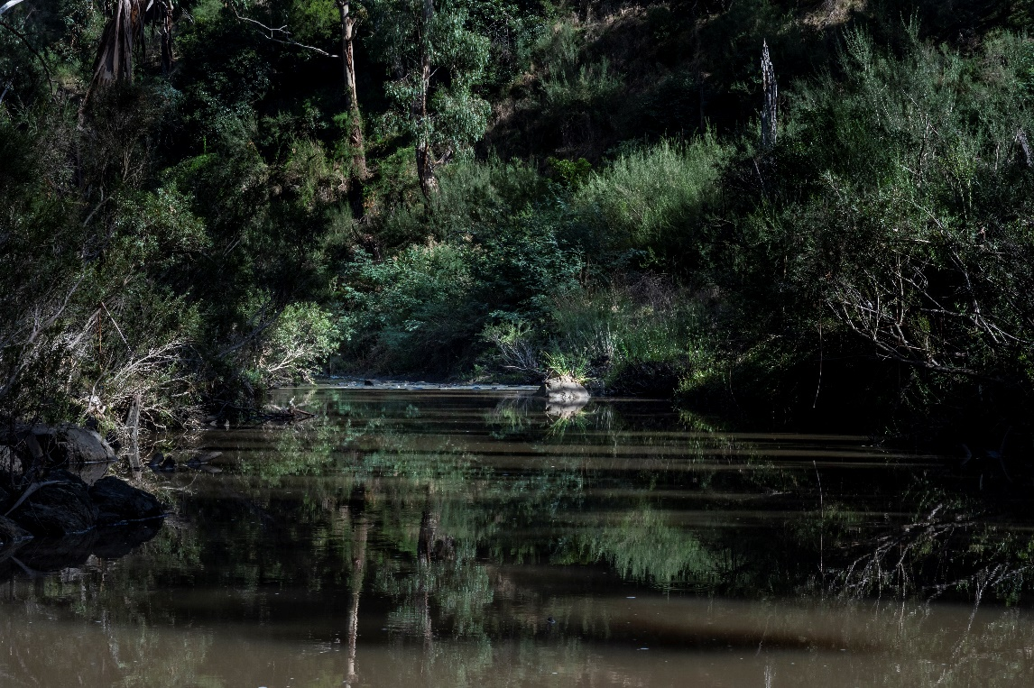

Photo by: Doug Gimesy 8 April 2024

The specific objectives for the Plan are:

1. To manage stream flows with natural variability, in line with the environmental flow objectives of the Yarra Catchment flows study~~.~~
2. To manage extraction of water within the sustainable water allocation for the Plenty River catchment.
3. To ensure that stream flows are managed to meet the agreed minimum environmental flows (ban or trigger levels).
4. To ensure that the transfer of licences will not negatively impact on existing licensed water holders or the environment.
5. To manage and minimise the risks to diverters, the waterway and ecological values.

## 1.3 Plenty River Local Management Plan

The Plenty River catchment (Figure 1) in the Yarra River Basin is approximately 351 Sq. Km in area and originates from the slopes of Mount Disappointment in the Great Dividing Range located about 50 Km north of Melbourne. The river flows generally north to south with the protection area extending from the Great Dividing Range north of Whittlesea to the junction with the Yarra River at View Bank/Lower Plenty. The main sub-catchments of Plenty River are Scrubby Creek, Plenty River East and West (Crystal Creek) Branches and Bruce’s Creek which join at Whittlesea to form the Plenty River. The other major tributary is Barbers Creek, which enters Plenty River about nine Km downstream of Whittlesea.

There are two main water storages in the catchment:

* Toorourrong Reservoir, which is a 300 ML capacity storage located on the Plenty River East Branch, receiving inputs from the Plenty River, Jack Creek and an inter-basin transfer from Wallaby Creek in the Goulburn River basin; and
* Yan Yean Reservoir, which is a 30,227 ML off-stream storage dam located between Whittlesea and Mernda. Yan Yean receives water from Toorourrong Reservoir via an aqueduct known as the "Clear Water Channel".



photo by: Doug Gimesy 8 April 2024

Upstream of the rural areas, the Plenty River runs through Kinglake National Park and the closed catchment of Toorourrong Reservoir . The rural reaches of the Plenty River system extend from the State Forest and National Park areas downstream to approximately Mernda. Downstream of Mernda the adjoining land use is a combination of rural and urban, with extensive urban development occurring. The other dominant land use in this reach is public open space with Plenty Gorge Park straddling the River for approximately nine kilometres. The River downstream of Plenty Gorge Park flows through the predominantly developed urban areas, of Greensborough, Montmorency and Lower Plenty, until it meets the confluence of the Yarra River.

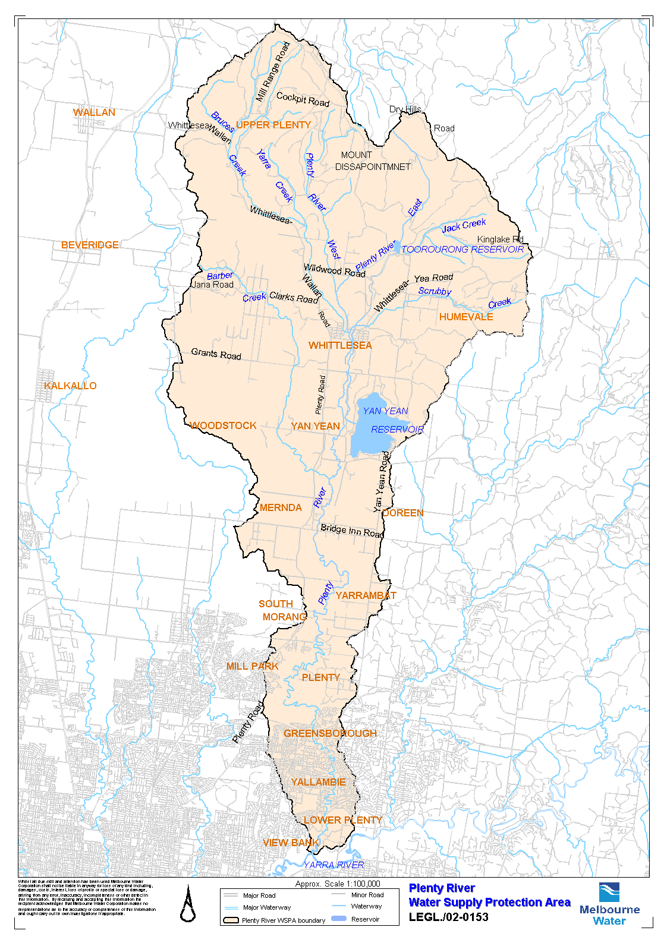

Figure The Plenty River catchment

## 1.4 Environmental Values

The Plenty River has been identified as an important wildlife corridor linking Kinglake National Park with the closed catchment of Yan Yean Reservoir and Plenty Gorge Parklands. The fauna of the Plenty River represents a diverse biological community that relies on the instream and riparian zones of the catchment.

Instream habitat values along the Plenty River and its tributaries vary remarkably. Toorourrong Reservoir, Yan Yean Reservoir and Plenty River Gorge provides some of the highest value habitats for indigenous aquatic flora and fauna, including endangered species such as the Macquarie perch .

The upper steep forested areas, upstream of Toorourrong Reservoir and the tributary headwaters, is relatively ecologically healthy, with significant areas of intact vegetation and moderate to high conditions for platypus, frog (including the Growling Grass Frog) and macroinvertebrate populations (Melbourne Water, 2018).

The upper catchment (below Toorourrong Reservoir) is home to important River Red Gum and grassland habitat, including the critically endangered Grassy Eucalypt Woodland ecological community, ecological community under the EPBC act. Under the Melbourne Strategic Assessment there is a 1,200 hectare grassy eucalypt woodland protected area. (DELWP 2021)

A number of deep pools which are significant for fish species such as the river blackfish occur in this reach of the stream. However, the blackfish surveys in 2019 using eDNA (Weeks, 2019) returned negative results for blackfish in the Plenty River and are likely to be further threatened by reduced flows under climate change or unseasonal dry periods.

The upper catchment from the confluence of Bruces Creek and Scrubby Creek in Whittlesea, downstream to Hazel Glen Drive hold important floodplain values, particularly for Red Gum Swamp (EVC 292) and Swamp Scrub (EVC 53) which are both endangered within the Victorian Volcanic Plain bioregion (DEECA2023).

Dunnetts Swamp, which is one of Melbourne Water’s Sites of Biodiversity Significance is home to the Red Gum Swamp EVC and endangered flora species such as the Amphibromus fluitans (River Swamp Wallaby-grass).

Jacobs 2023, undertook a Hydrology and Threatened Flora Investigation in 2023 to understand the hydrological conditions causing River Red gum dieback and to investigate options to improve River Red Gum populations in providing options for delivering environmental water during dry years or allowing for partial drainage in abnormally wet conditions. One of the recommendations from the report is to implement water level monitoring and revisit the management plan once 2 years or more of data is collected. One of the important inundation preferences for the long-term health of Dunnetts swamp and the River Red Gum community is after prolonged absence of inundation for more than 3 years should trigger environmental watering.

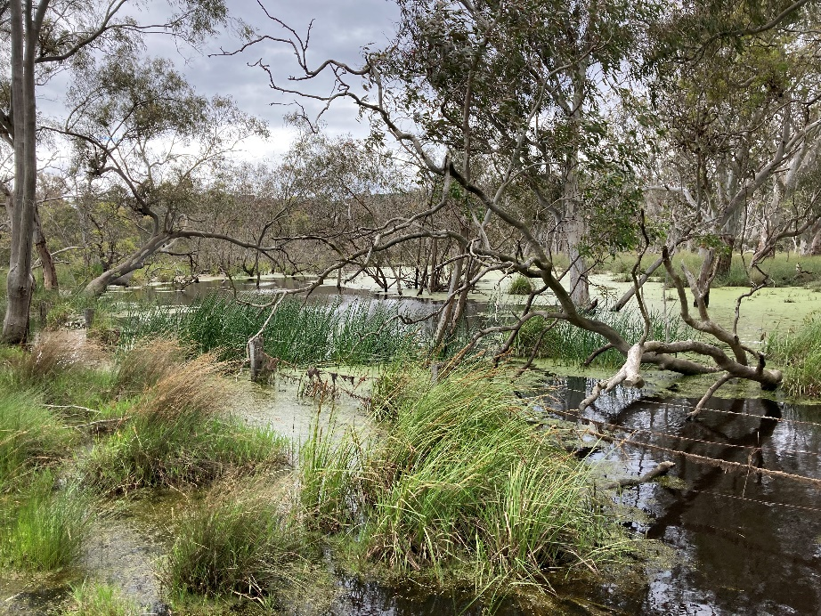

Figure X: Dunnets Swamp

A healthy population of platypus once existed in the upper reaches of the Plenty River in Toorourrong Reservoir and in upstream tributaries (data not shown). Over the last 15 years this population has declined dramatically to the point where it may now be locally extinct, although eDNA monitoring returned positive results in 2021 and 2022.

The lower portion of the catchment (downstream of South Morang) is heavily urbanised with some light industry, while the plains upstream of South Morang have been extensively cleared. Condition ratings (Melbourne Water, 2018) suggest a general decline in overall environmental value as the river heads south (downstream) towards its confluence with the Yarra River.

More information on the environmental values for the Plenty River catchment can be found on the Melbourne Water Healthy Waterways Strategy website, [Key values | Healthy Waterways Strategy](https://healthywaterways.com.au/key-values).

**TO Values?**

## 1.5 Environmental Flows

Aquatic life adapts to the natural patterns of high and low stream flows to survive. Changes to these natural patterns may put existing aquatic life at risk. For example, stream flows are naturally low during droughts and so the aquatic life develops ways to survive occasional droughts. But if stream flows mimic drought conditions every year because of the extraction of water, then aquatic life may not be able to survive. One way to protect, maintain and enhance aquatic life is to develop a seasonally appropriate flow regime (usually closely related to the natural flow patterns) to support the habitat and life-cycles of these species.

To ensure the long-term sustainability of the water resource whilst protecting the values in the catchment, an Environmental Flows study was undertaken for the Yarra River (SKM 2005) which included the Plenty River (downstream of Toorourrong Reservoir to Mernda) as Reach 9. The Environmental flow recommendations for specific flow components that are considered important are:

* Cease to flow;
* Summer and winter low flows;
* Summer and winter freshes and high flows;
* Bankfull flows; and,
* Overbank flows.

It should be noted that the environmental flow recommendations for the Plenty Rive (Reach 9) were not included in either of the 2012 and 2018 reviews of the Yarra River Environmental Flow studies.



2. Water Use

## 2.1 Licenced Water Entitlements

In the Plenty River catchment, **660 ML of water** is currently allocated for diversion by licenced customers each year. This water is taken under licenses issued under section 51 of the Act and in accordance with the policies issued by the Department of Energy, Environment and Climate Action (DEECA). A licence allows water to be taken from a waterway or dam up to the volume and for the purpose specified in the licence.

Section 51 of the Victorian Water Act 1989 generally fall into one of the following categories:

1. ***All-year licences:*** A licence issued with conditions that allow pumping from a waterway, or harvesting water in a dam, during any month of the year up to the licensed volume.
2. ***Dam-filling (winterfill) licences****:* A licence issued with conditions that allow filling of an on or off stream dam during the dam-filling period, typically by pumping from a waterway into a dam or collecting water in the dam onstream.
3. ***Farm dam licence:***This licence allows a person to take water from **catchment dams** that were historically utilised for **irrigation**. The difference between these licences and **farm dam registrations** is that farm dam licences can be traded and incur annual fees. Farm dam licences cannot be converted to farm dam registrations.
4. ***Farm dam registration:*** This covers **catchment dams** that were historically utilised for **irrigation** or **commercial** purposes prior to the *Water (Irrigation Farm Dams) Act 2002*. They are granted in perpetuity and transfer with the property. Farm dam registrations can be converted into farm dam licences.

Table 2 below summarises the licenced water entitlements in the Plenty River. More information are available in the Victorian Water Register : [Water entitlements - Water Register](https://www.waterregister.vic.gov.au/water-entitlements)

Table 2 Number of Licence and Volume by licence type

|  |  |  |  |  |
| --- | --- | --- | --- | --- |
| **All Year**  **Licence** | **Winter-fill**  **Licence** | **Farm Dam Registration** | **Farm Dam**  **Licence** | **TOTAL** |
| **No. Vol.** | **No. Vol.** | **No. Vol.** | **No. Vol.** | **No. Vol.** |
| 8 49ML | 8 315ML | 18 286ML | 1 10ML | 35 660 ML |

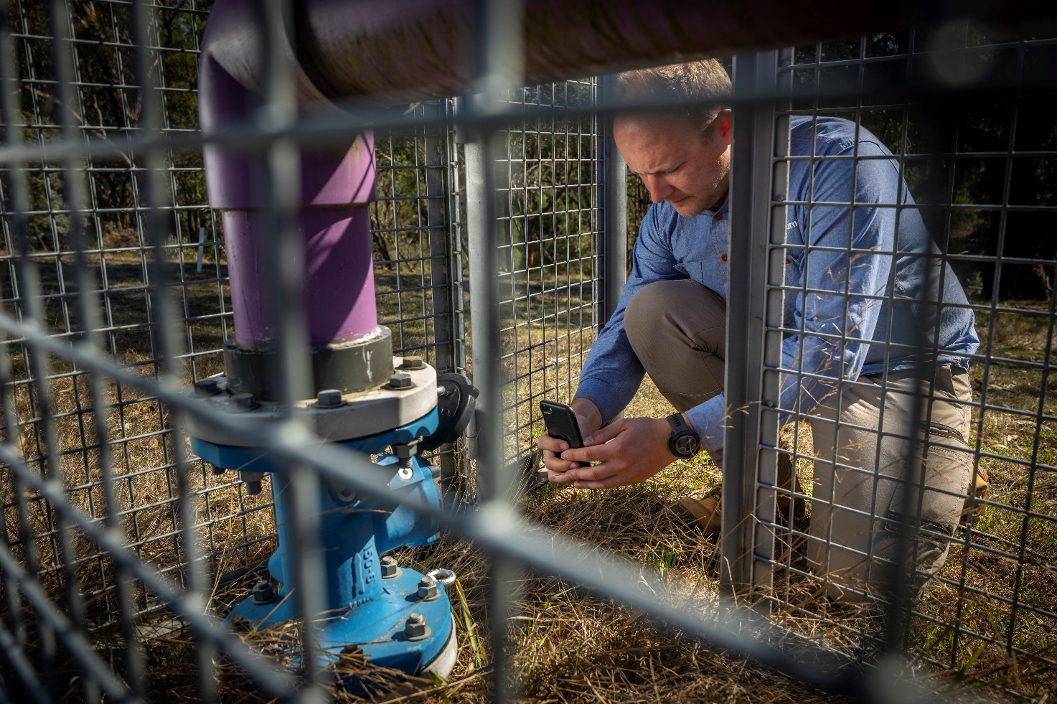

photo by: Doug Gimesy 8 April 2024

## 2.2 Domestic and Stock Use

Water can also be taken for domestic and stock use without a licence if a person owns land with direct frontage to a waterway, if the waterway flows through a person’s property, or if rainfall run-off is collected in a dam and not used for commercial irrigation[2]. As this use is not licensed, water used can only be estimated. Accessing water for these purposes is a well-recognised private right for all landholders and does not require a licence as detailed in Section 8 of the Water Act (1989).

In 2012, Melbourne Water conducted a study into unlicensed water use in the Plenty River catchment[3]. The purpose of the study was to estimate how much water is being accessed outside of the licensing framework for purposes such as domestic and stock use. It is important to understand these demands and their impact on stream-flows in the overall context of managing the water resource for all users.

The domestic and stock demand study indicated that this use in the Plenty catchment is approximately 740 ML per year which is higher than the licenced allocation (110% of licenced allocation), with domestic demand constituting 70% of this amount (RMCG, 2012).

* Farm dam development in the Plenty River is high (16ML/km2) compared to the typical level of development in Victoria (1 to 10 ML/km2).
* The impact of farm dams on streamflow is high compared to other direct irrigation demands in the catchment.
* Most (~90%) of the farm dam development in the catchment is unlicensed farm dams for stock and domestic use (SKM, 2012).

## 2.3 Groundwater

Southern Rural Water manages groundwater licenced diversions in the Yarra Basin, including those associated with the Plenty River catchment. Studies by (SKM 2011) of groundwater dependent ecosystems provide valuable information regarding groundwater sources in the Plenty River catchment.

Groundwater use in the Plenty catchment is low, with only one licenced groundwater extraction bore located nearby (SRW 2024 Pers. Comm., 7 May).

Under the framework for managing groundwater in Victoria (Victorian Government 2024), the Plenty River catchment is within the East Port Phillip Bay Groundwater Catchment. There are no incorporated groundwater management areas in the Plenty River catchment. There are also no Water Supply Protection Areas or Groundwater Management Areas.

3. Surface Water Management

## 3.1 Allocation

. The 2007 SFMP set an allocation cap for the+ plan at 669 ML per year (including farm dam registrations).

Trading and transfer rules have been set in this plan in order to meet the allocation cap (see Section 3.4.2). In addition, some licences may be cancelled, surrendered or transferred out of the catchment. If this happens, the limits on the allocation cap and all-year licences will be decreased by the amount cancelled, surrendered or transferred out. As it currently stands, the allocation cap for the Plenty River catchment is 660 ML.

The wetter months of the year are typically June to November in this catchment. As per the Statewide Take and Use Policies, anyone with a winter-fill licence is able to take water during the months from 1st July to 31st October, in addition to all-year licence holders.

All year licences are able to take water at any time during the year (subject to bans). The allocation cap for the all-year direct extraction from waterway (excluding Farm Dams) is set at 49 ML.

|  |
| --- |
| **Rule 1: Cap on surface water allocation in Plenty River**   1. Melbourne Water will:    1. Put in place a total allocation cap for the Plenty River catchment at the existing level of allocation as of 30 June 2024 – 660 ML    2. Reduce the allocation cap by the volume of any allocation surrendered or transferred out of the Plenty River catchment    3. Put in place an allocation cap for all-year direct extraction from waterway within the Plenty River catchment of 49 ML. 2. Melbourne Water will not issue a licence under section 51(1)(a) or (ba) of the Act in the Plenty River Catchment that will cause any of the allocations caps described in (1) above to be exceeded. |
|  |

## Environmental Flows

The implementation of minimum environmental flows will be achieved through applying the existing flow triggers that bans access to extract water. The minimum flows are based on the recommended environmental flows from the Assessment of Environmental flow Requirements for the Plenty River Catchment (Lieschke et al, 2000).

To assist in achieving the minimum environmental flows on a daily basis, a maximum daily volume will be set so that no greater than five percent of the annual volume can be taken.

|  |
| --- |
| **Rule 2: Maintaining Environmental Flows**   1. Melbourne Water will amend conditions on existing Section 51 licences to ban extraction of water from waterways in the Plenty River catchment when flows fall below the levels outlined in Appendix 1. 2. Melbourne Water will amend conditions on existing Section 51 licences to limit the maximum daily volume so that it is not greater than five per cent of the annual volume. |
|  |

The status of environmental flows for the catchment along with the streamflow data will be updated daily on the Melbourne Water website at [www.melbournewater.com.au/diverters](http://www.melbournewater.com.au/diverters) or available by calling Melbourne Water on 131 722. The website will communicate the applicable status of bans, status of restriction if applicable, current catchment warning level, daily streamflow and 7-day average streamflow. It is a condition of their licence that licence holders check this website prior to taking any water.

Restrictions/rosters

Melbourne Water may, from time to time, prepare and implement rosters or restrictions or other arrangements for taking and using water, in accordance with the principles specified in Melbourne Water Drought Response Plan for Licensed Water Users.

## 3.4 Surface Water Licences

### 3.4.1 New Licences

No new licences will be issued under this plan that will cause an allocation cap to be exceeded.

### 3.4.2 Trades and Transfers

As no more new licences are being issued in the Plenty River catchment, licence transfers are the only mechanism to obtain water and promote water use efficiency by establishing a market to sell unused entitlements and provide access to water. However, transfers also have the potential to increase the overall water use, as unused licences become active.

Any application for an upstream trade or transfer may be considered in line with the current state policy and subject to investigation for potential impacts to existing water user reliability of supply and the environment.

|  |
| --- |
| **Rule 3: Trades and Transfers of surface water entitlements**   1. Melbourne Water may approve a trade or transfer of a licence under section 62 of the Act provided that relevant matters under section 53 of Act have been considered and that the following conditions are satisfied:    1. The issuing of the licence will not result in the allocation limits specified in Rule 1 being exceeded.    2. For upstream trades/transfers:       1. The conditions on the licence are amended so that water may only be taken or collected during the winter-fill period.       2. Will be considered according to current state policy and subject to assessment for potential impacts to existing water user reliability of supply and the environment.    3. For downstream trades/transfers:       1. licence conditions should be amended to only allow take during winter fill period, to be assessed based on each application. |
|  |
|  |

### 3.4.3 New Dams

The Act defines a private dam as *‘anything in which by means of an excavation, a bank, a barrier or other works water is collected, stored or concentrated’* but **does not** include:

a) anything owned or operated by a public statutory body; or

b) any works of an Authority or a licensee; or

c) a channel, drain or pipe; or

d) a bore.”

4. Monitoring, Evaluation & Reporting

Monitoring, evaluation and reporting are vital for ongoing improvement in water resource management. The results allow adaptive management and input into the future review of management actions.

## Surface Water Flows

In the Plenty River catchment, surface water flows are monitored daily at Mernda (Gauge ID : 229616A). For compliance to meet the minimum environmental flows in this plan, Mernda will be the compliance gauge. Flow data will be posted and updated daily on the Melbourne Water website at [www.melbournewater.com.au/diverters](http://www.melbournewater.com.au/diverters) and is available by calling Melbourne Water on 131 722.

Melbourne Water must:

1. continuously record flows at the Mernda gauging station (Gauge ID : 229616A), and
2. periodically inspect the condition of the Mernda gauging station;
3. maintain the Mernda gauging station in good condition;
4. keep a record of each inspection and all work undertaken.

## Meter Readings

Effective water resource management relies upon information about water usage patterns and volumes. This information will be collected by metering extractions. Melbourne Water will install meters to measure any water that is taken under licence. Meters are not required for licences less than 5ML in volume or for licences that are inactive but where Melbourne Water consider it beneficial, meters may be installed for licences under 5ML. There are five licences that are metered within the Plenty River catchment as of 30 June 2024. Melbourne Water must read all-year licence meters annually and read dam-filling licence meters at the start and end of the dam-filling period each year.

Melbourne Water has installed some smart meters within the catchment. The meters have data loggers linked via communications, allowing the data to be downloaded in the office and the information viewed over a secure web link. The information will be stored in the Victorian Water Register database to assist with reporting on usage and compliance.

|  |
| --- |
| **Rule 4: Install Meters and record meter readings**  Melbourne Water will:   1. Ensure that a flow meter is fitted to all operating licenced extraction points, associated with a licence to extract 5 ML or more of water a year under Section 51(1)(a) of the Water Act. 2. Ensure that a flow meter is fitted to all operating licenced extraction points, associated with a licence to extract less than 5 ML if Melbourne Water considers it beneficial. 3. Read each meter at least once annually for all-year licence holders and shortly after the beginning and end of the winter-fill period in every year for winter‑fill licence holders. |
|  |

## Annual Reporting

Melbourne Water will report on the implementation of Plenty River Local Management Plan each year as part of the Melbourne Water Unregulated Rivers and streams Local Management Summary. The report will include information on total entitlements issued, metered water use, trades and transfers and mean daily flow at Mernda gauge each year. A copy is to be made available on the Melbourne Water website.

All monitoring information will be stored at Melbourne Water’s applicable databases. All stream-flows are recorded daily and available to view on Melbourne Water’s website as explained in Section 4.1.

|  |
| --- |
| **Rule 5: Annual Reporting**  Melbourne Water will prepare information for the previous water year (1st July-30th June) to be included in an annual summary of LMP/LMR implementation and post on the Melbourne Water website. This may include:   1. Total Surface Water entitlements in the catchment; 2. Any trading and transfers of licenses issued under Section 51 (1) (a) and (b) to or from the Plenty River catchment 3. Metered surface water use in the catchment 4. Any periods when roster and restrictions were in place 5. Any compliance and enforcement action taken 6. Flow monitoring data from Mernda gauge |
|  |

## Review of the Plan

Over time this Plan may need to be changed in response to any state-wide policy changes to surface water resource management and as any management improvements are identified or entitlements and rules are changed or updated in the system.

Melbourne Water will regularly consider the need to make an amendment to the Plan based on sound technical understanding of the issues and will be subject to consultation.

|  |
| --- |
| **Rule 6: Review of the Plan**  Melbourne Water will consider the need for any amendments to the Plan as necessary.  If any amendments are proposed that directly impact on the rights of access to water, Melbourne Water will consult with surface water users in the catchment on the proposed changes to the Plan. |

# References

DEECA 2023, [Bioregions and EVC benchmarks (environment.vic.gov.au)](https://www.environment.vic.gov.au/biodiversity/bioregions-and-evc-benchmarks). https://www.environment.vic.gov.au/biodiversity/bioregions-and-evc-benchmarks

DELWP 2021, Strategy for establishing a Grassy Eucalypt Woodland Protected Area, Melbourne Strategic Assessment. ISBN 978-1-76105-567-6 (pdf/online)

[Grassy eucalypt woodland protected area (msa.vic.gov.au)](https://www.msa.vic.gov.au/conservation-in-action/grassy-eucalypt-woodland-protected-area) <https://www.msa.vic.gov.au/conservation-in-action/grassy-eucalypt-woodland-protected-area>

Jacobs 2023, Dunnetts Swamp Hydrology and Threatened Flora Investigation Summary Report Final v2.

Lieschke J, Grgat L & Zampatti B, 2000, An assessment of environmental flow requirements for the Plenty River Catchment, Parks Flora and Fauna, Natural Resources and Environment. A Report for Melbourne Water

Melbourne Water Corporation 2007 (MWC, 2007), Plenty River Water Supply Protection Area Stream Flow Management Plan.

Melbourne Water Corporation 2018, Healthy Waterways Strategy, Melbourne water website: https://healthywaterways.com.au/

SKM 2005, Determination of the Minimum Environmental Water Requirements for the Yarra River Final Report.

SKM 2011, Identification of Groundwater Dependent Ecosystems within Melbourne Water Catchments. Final Report May 2011.

SKM 2012, Understanding the impact of farm dams on streamflow in the Plenty River catchment, Summary Report.

RMCG 2012, Stock and Domestic Water Use Estimates High-level Approach, Olinda, Plenty, Steels, Pauls & Dixon and Stringybark Catchments. Final Report.

Victorian Government 2024, Victorian Water Accounts 2021-2022: https://accounts.water.vic.gov.au/local-water-reports/groundwater-by-area/east-port-phillip-bay/

Victorian Water Register: <http://waterregister.vic.gov.au/>

Water Act 1989 (Vic), No. 80 of 1989, Authorised Version incorporating amendments as at 20 November 2023.

Weeks, A., 2019, River blackfish surveys using environmental DNA in the Plenty River autumn 2019, Report prepared for Melbourne Water, EnviroDNA

# Appendix -1

### LICENCE CONDITIONS

1. Licence to take and use water from a waterway for any purpose: [section 51(1)(a)]

1.1 The Licensee must not:

(a) take any water from a waterway when the average stream flow at Mernda gauging station:

(i) is 1.5ML per day or less, at any time between 1 December and 31 May, in any year; and

(ii) is 2ML per day or less, at any time between 1 June and 30 November, in any year;

1.2 The Licence holder must comply with any roster or restriction prepared and implemented by Melbourne Water as set out in the Melbourne Water Drought Response Plan for Licensed Water Users.

1.3 The Licensee must in order to determine their entitlement to take water from a waterway, check the restriction or ban status within their catchment before taking water under their licence, either by calling 131 722 or at the website [www.melbournewater.com.au/diverters](http://www.melbournewater.com.au/diverters).

2. Licence to take water from a waterway to fill a dam: [section 51(1)(a)]

The Licensee must not take water from a waterway or collect water to fill a dam, whether the dam is built on or off a waterway, between 1 December and 31 May in the following year.

3. Licence to use water from a dam constructed after the commencement of Plenty River Local Management Plan 2024: [section 51(1)(ba)]

The Licensee must not allow water (other than rain water supplied to a dam from the roof of a building, or a bore) for use other than domestic and stock use to collect in the dam between 1 November and 31 May in the following year.

4. Licence to take and use water transferred into or upstream within the Management Plan area: [section 62(3A), 62(6)(b)]

The Licensee must not take any water from a waterway or collect water in a dam between 1 November and 31 May in the following year.

Will be considered according to current state policy and subject to assessment for potential impacts to existing water user reliability of supply and the environment.

Note: These conditions are additional to, or replace, existing licence conditions where appropriate.

1. Currently these are the Ministerial Policies for Managing Take and Use Licences 2016.
2.
3. The figures from the study should be taken as general information under the understanding that there has been significant urbanisation occurring in the Plenty River Catchment since the 2012 studies.